Why main method accepts only string type of argumnets.

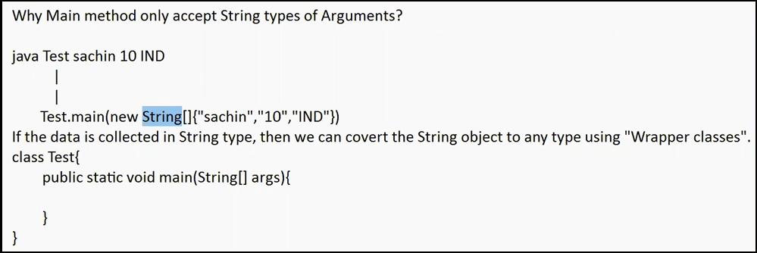



**Encapsulation:**

Grouping of different data items. Process of keeping data member as Private and exposing those value to the outer world through getters/setter is called encapsulation.